Hanna Alemu
CS 330: Computational Graphics and Visualization
October 2026
Final Project Design Decisions
Development Choices
For this project I recreated a photo of a round wood coffee table in a neutral living room. I picked it because almost everything in it breaks down into simple shapes. The table is my complex object a short, wide cylinder for the top and two boxes crossed in a plus sign for the base, which matches the legs in the photo. On top of the table I added a clay pot (a squashed sphere with two cylinders for the neck and lip), a vase (a tapered cylinder with a cylinder neck and three thin box branches with small pyramid blossoms), two books (boxes), and a small bowl (a half sphere on a cylinder foot). The floor and back wall are planes and the rug is a very flat cylinder. Altogether the scene uses boxes, cylinders, planes, spheres, a tapered cylinder, and pyramids.
I placed the table at the origin and saved its top height in one constant, TABLE_TOP_Y, so every object on the table is positioned from that surface instead of from guessed numbers. That made it easy to move things around until the layout matched the photo. For the textures I used seven free 1024 x 1024 images from Poly Haven: oak planks for the top of the table (Savva, 2026), oak veneer for the edge (van Heerden, 2026), rosewood for the legs (van Heerden, 2024), floor tiles (Baglioni, 2025), a cream fabric for the rug (Cilliers & colormass, 2025), brown linoleum for the clay pot (Tuytel, 2025), and long white tiles for the wall (van Heerden & Majboroda, 2024). I tiled the floor 6 by 3 so the tiles don't stretch. Each surface also has its own material, so the glazed vase and bowl get a sharp highlight while the clay, rug, and books stay matte.
For lighting I used four point lights. The main one is a warm amber light above and in front of the table, which is the colored light and matches the warm tone of the photo. A cooler light from the left acts like window light, a dim lamp at the back left lights the back of the objects, and a low fill light lights the underside of the tabletop. Together they cover all three parts of the model: ambient, diffuse, and specular. One thing I learned is that the course shader only uses each light's ambient color for tinting, so I set the amber light's ambient value high enough for the color to actually show up.
Navigating the Scene
The camera works like a first person camera. W and S move forward and backward, A and D move left and right, and Q and E move up and down. Moving the mouse changes where the camera is looking without moving its position, and scrolling the mouse wheel speeds up or slows down how fast the camera moves. Pressing O switches to an orthographic (2D) view and P switches back to perspective (3D). Only the projection matrix changes, so the camera keeps the same position and direction. I also added R to reset the camera to its starting view, which helps if the user gets lost. Movement uses the time between frames, so the speed stays the same no matter how fast the computer runs.
Custom Functions
I split the scene into small functions so RenderScene() reads like a list of what's in the room. Each object has its own function, like RenderCoffeeTable() and RenderClayPot(), and the objects on the table take a base position, so the same pot or vase could be drawn anywhere just by passing a different point. RenderBlossomBranch() is the most reusable one. It takes a start point, a length, and two tilt angles, works out which way the branch points, and places the blossoms along it, so the vase calls it three times to get three different branches. RenderBookStack() returns the height of the stack, which lets the bowl sit on top of the books without hard-coding its height. I also wrote SetTexturedSurface() and SetColoredSurface() so setting a texture, its UV scale, and a material takes one line, and SetupSceneLights(), LoadSceneTextures(), and DefineObjectMaterials() keep all the setup code in one place each. Splitting things up this way made the scene a lot easier to adjust and debug as I added each object.

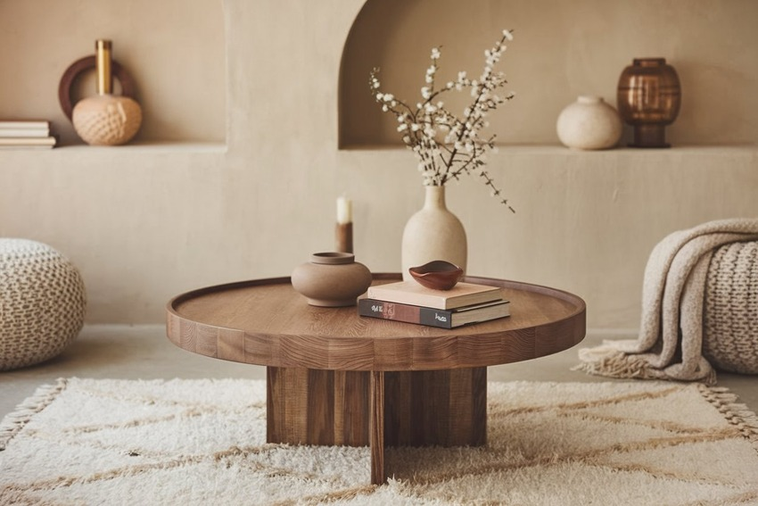References
Baglioni, C. (2025). Interior tiles [Texture]. Poly Haven. https://polyhaven.com/a/interior_tiles
Cilliers, R., & colormass. (2025). Curly teddy natural [Texture]. Poly Haven. https://polyhaven.com/a/curly_teddy_natural
Decorpot. (n.d.). Mark your wishlist done with this trendy and small coffee table design. Retrieved October 16, 2026, from https://www.decorpot.com/blog/trendy-and-small-coffee-table-design
Savva, D. (2026). Oak wood planks [Texture]. Poly Haven. https://polyhaven.com/a/oak_wood_planks
Tuytel, R. (2025). Linoleum brown [Texture]. Poly Haven. https://polyhaven.com/a/linoleum_brown
van Heerden, J. (2024). Rosewood veneer1 [Texture]. Poly Haven. https://polyhaven.com/a/rosewood_veneer1
van Heerden, J. (2026). Oak veneer 05 [Texture]. Poly Haven. https://polyhaven.com/a/oak_veneer_05
van Heerden, J., & Majboroda, S. (2024). Long white tiles [Texture]. Poly Haven. https://polyhaven.com/a/long_white_tiles

